Lab exercise
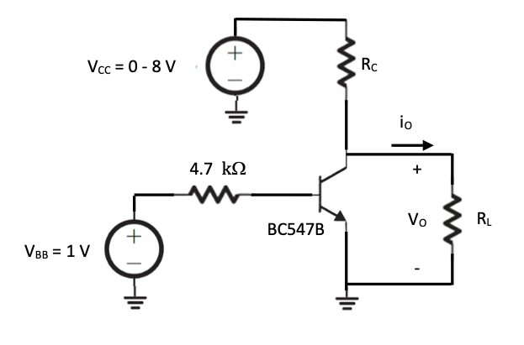

Part 1
$R_{C}=330Ω$
$V_{CC}≔8,0 V$
$V_{BE}≔0,7V$
$i_{C}=I_{S}e^{v_{BE}/V_{T}}$

Maske 1.
$1V-V_{BE}-i_{B}\left(4,7k\right)=0$
$1V-0,7V-i_{B}·4,7k=0$
$i_{B}=\frac{0,3}{4,7·{10}^{3}}≈6,382979·{10}^{-5}$
$i_{B}=63,8μA$

Betingelser:
$i_{C}=100mA,V_{CC}= 5V$
$β=180$

$i_{C}=63,8μA·180=0,011484 A$
$i_{C}=11,484 mA$

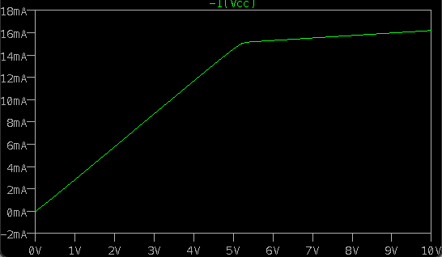
Part 1.b
$i_{C}$ :
Ved $V_{CC}=8V=>i_{C}=15,74mA, v_{O}=2,806V$

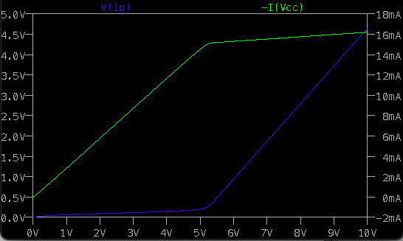

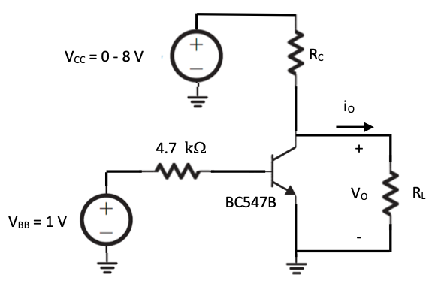
Part 1.c
Find thevenin ækvivalent til venstre for output.
’’’

Part 2.a
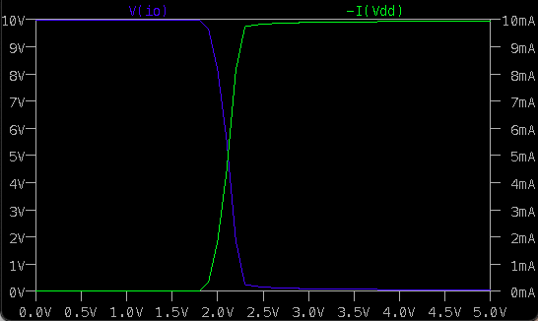

Part 2.b
$V_{GG}=3,0V$
$V_{t}=2,3$ - Aflæst af grafen for hvornår transistoren går i saturation mode.
$V_{OV}=V_{O}=V_{GG}-V_{t}=3V-2,3V=0,7 V$

